**WEBET333 PROJECT BASE TASK :**

|  |  |  |
| --- | --- | --- |
| **No.** | **Task Name** | **Estimated Developing Time line** |
| **1** | Add new User group | 4 Days |
| **2** | Add promotion code | 7 Days |
| **3** | Add free credit | 4 days |
| **4** | Add new type of promotion : PROMOTION FIXED BONUS AMOUNT | 3 Days |
| **5** | Two promotion code report | 1 Days |

** ALL TASK TIME LINE IS INCLUDING DEBUD AND FIX BUGS  
**ALL TASK TIMELINE I’M GIVING BUFFER MORE 1-2 DAYS ALREADY

1. **Add new user GROUP**

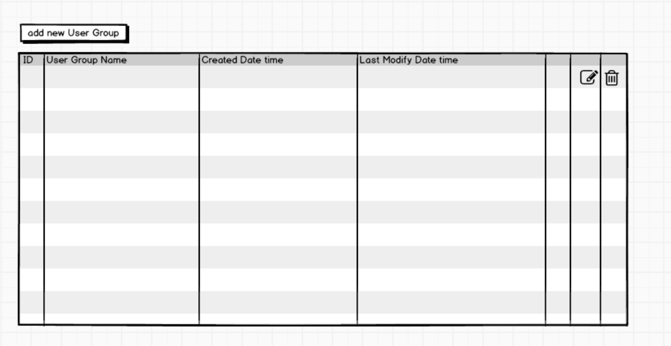  
1. Create new menu under setting for add new user group

2. user group is using for entitle promotion code and free credit usage.  
-example : username is in this user group, and entitle promotion code ILOVEWEBET, so, user when enter this promotion code at deposit page, user will get the special free bonus.

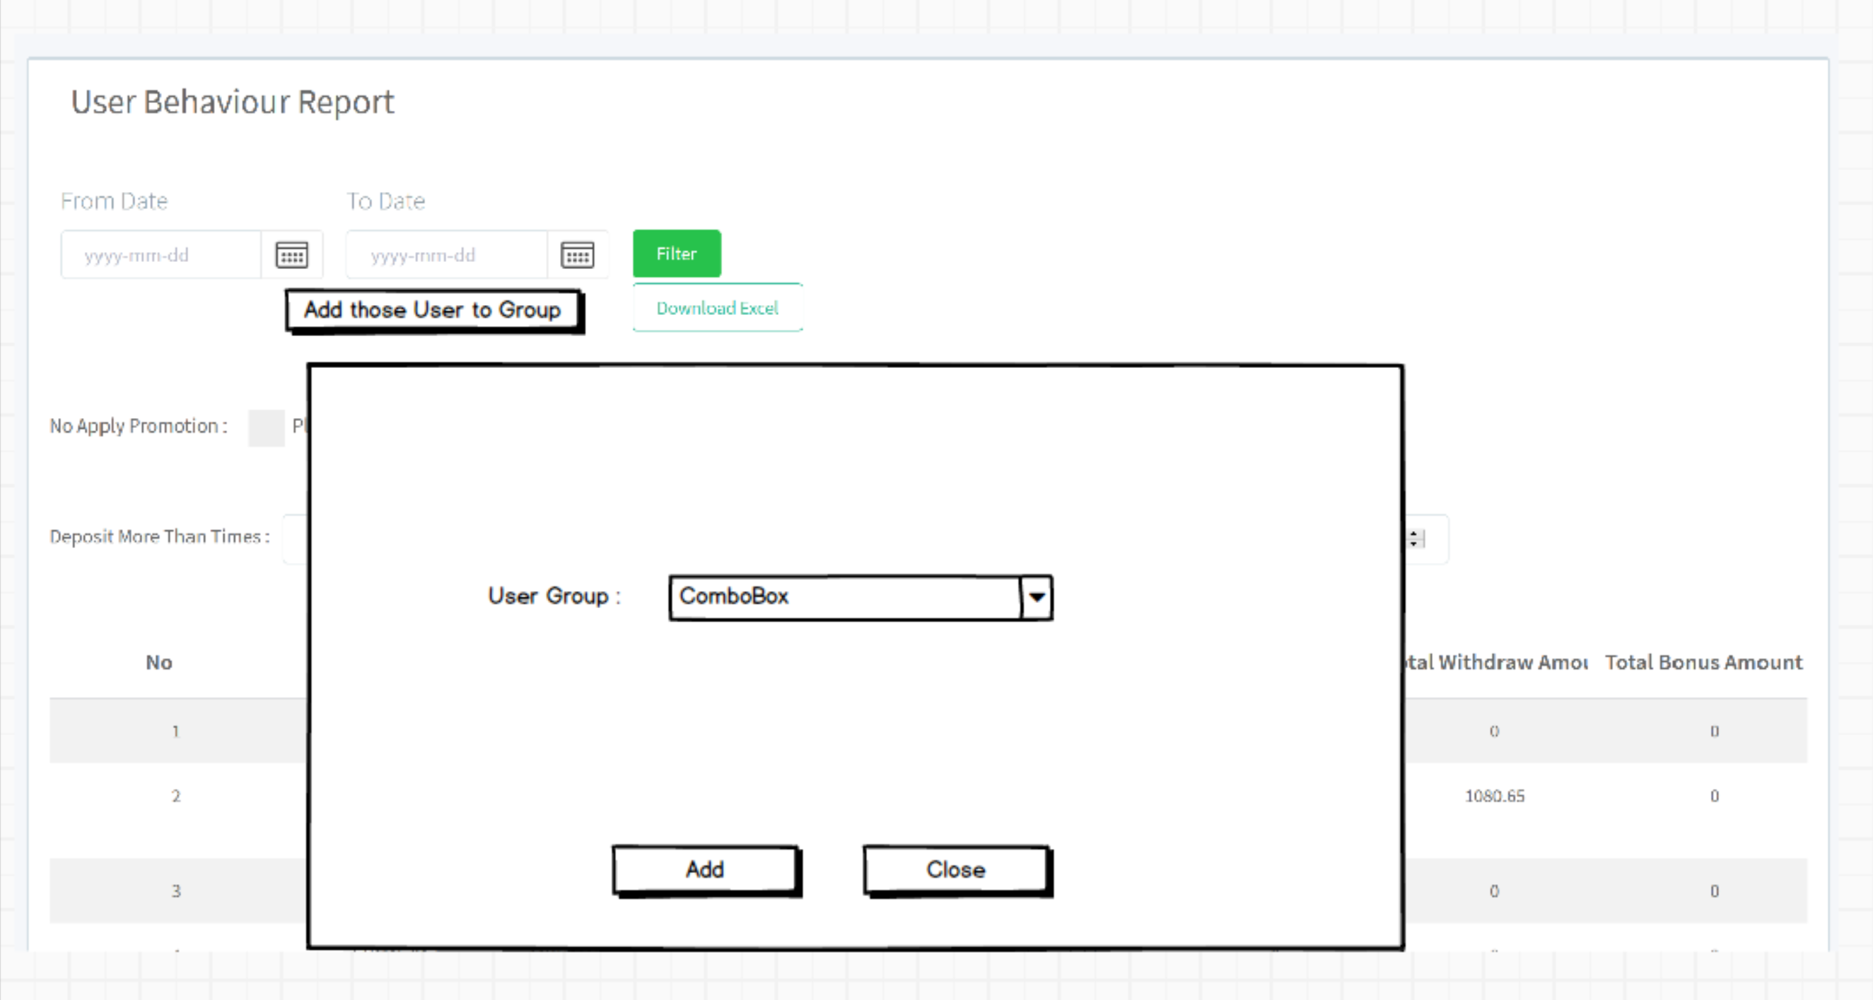

1. User Behaviour report and User register page add a “Add those user to group” button, so all those filtering user will add to the user group by each user ID
2. When add into group, user group need one more column in DB, it is winlose column, have to save user’s winlose value in the DB, it is using for free credit feature

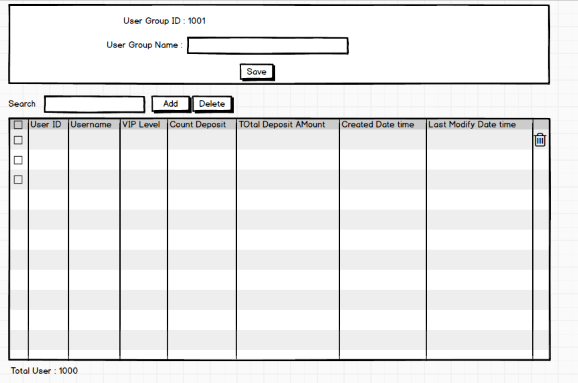

1. This is the page when click add new user group and edit
2. Admin can select all checkbox and click delete button, all user in this group will be deleted
3. Search can be search by user ID and username, and the data grid will filtering

**2.0 ADD NEW PROMOTION CODE**

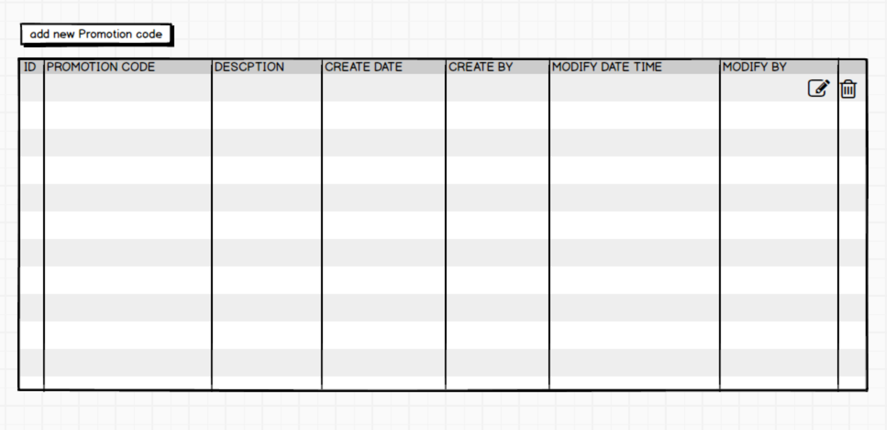

1. Add new menu in setting page, Add new promotion code, this feature is related to user group

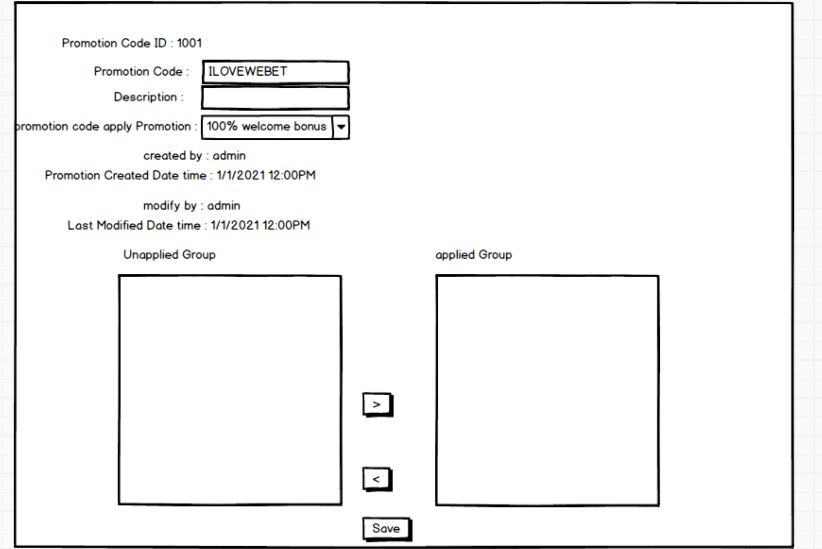

1. When click add new promotion code, this is the page
2. All unapplied group list will show all User group
3. Promotion code is link with User group ID in DB, if admin manually delete the user ID in the user group, that is mean user is not entitle the promotion code immediately.
4. Promotion code are allow same, but user ID only allow in one promotion Code. Example we have two promotion code is ILOVEWEBET, and user ID is 1001, 1001 user only allow in one of the ILOVEWEBET promotion, not allow in both. When adding user or adding group having to check this. When move unapplied group to applied group have to check this too.

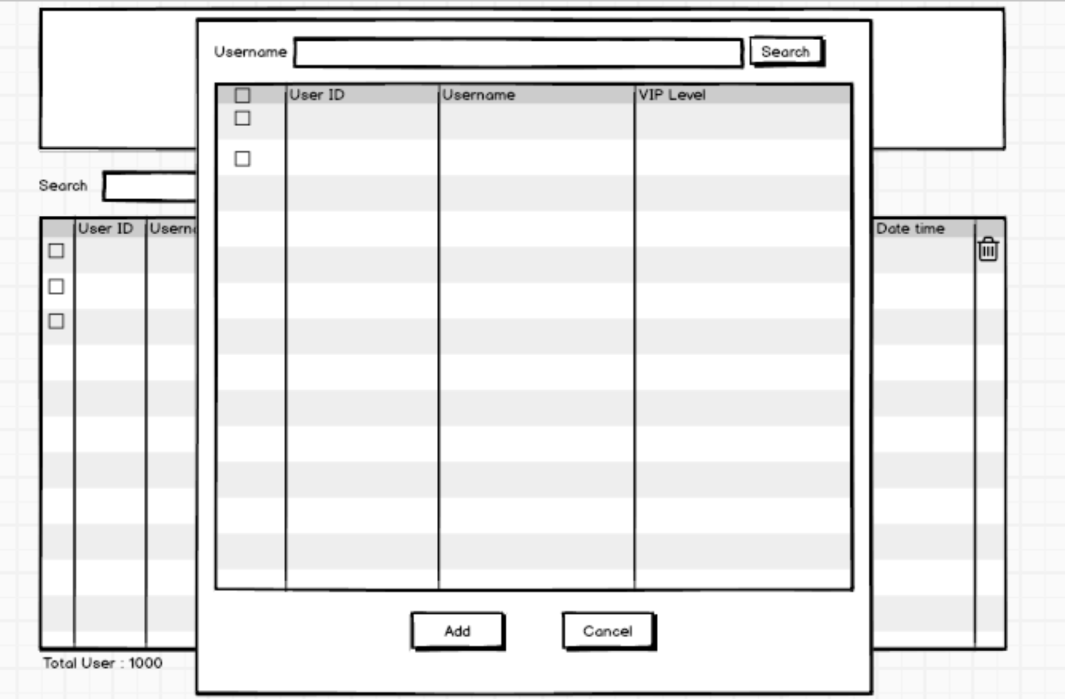

1. When click add user, can search user and checked the checkbox will insert into user Group
2. After clicked add button will be saved in DB

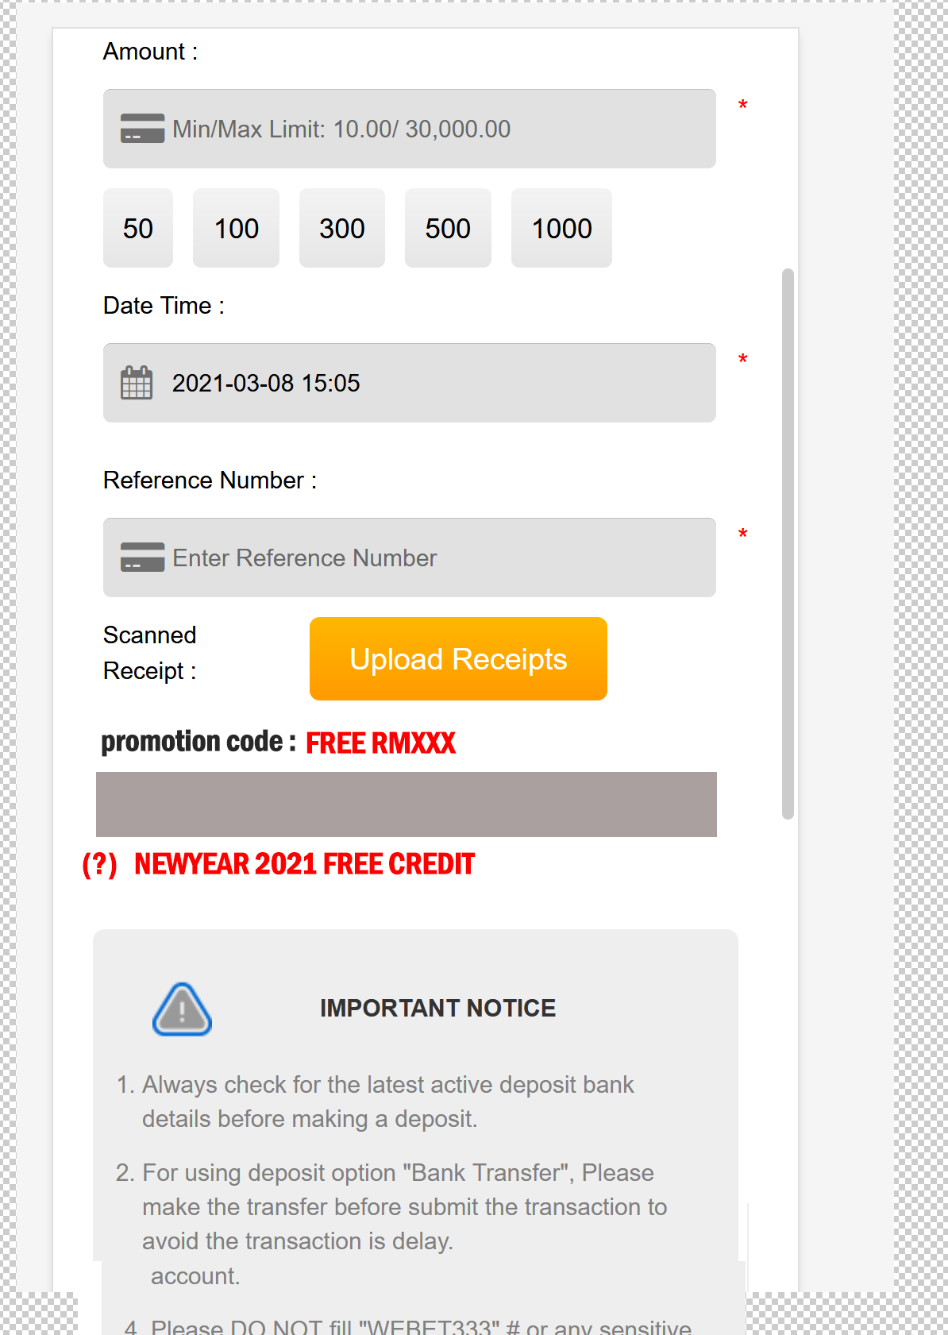

1. Please insert a promotion code text box after reference number text box
2. When user enter valid promotion code, will show the promotion name(NEWYEAR 2121 FREE credit) and beside promotion name will having a “?” icon, when user press on the ? icon, will popup the promotion description.
3. implement in mobile and desktop version
4. FREE RMXXX will be the amount of the free credit, this text with red color and upper capital

**3.0 ADD NEW FREE CREDIT EVENT**  
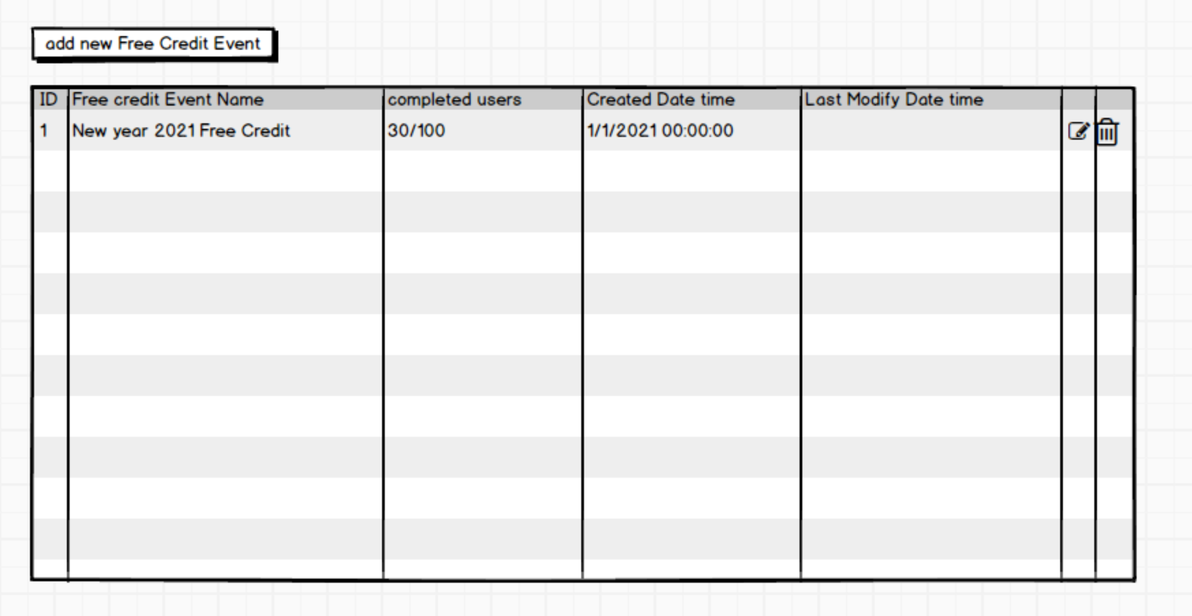   
1. add free credit task in setting menu  
2. If admin press delete button, will according the user free credit remove it and main wallet balance will be deduct, if the user main wallet is 0, main wallet balance will become negative.  
  
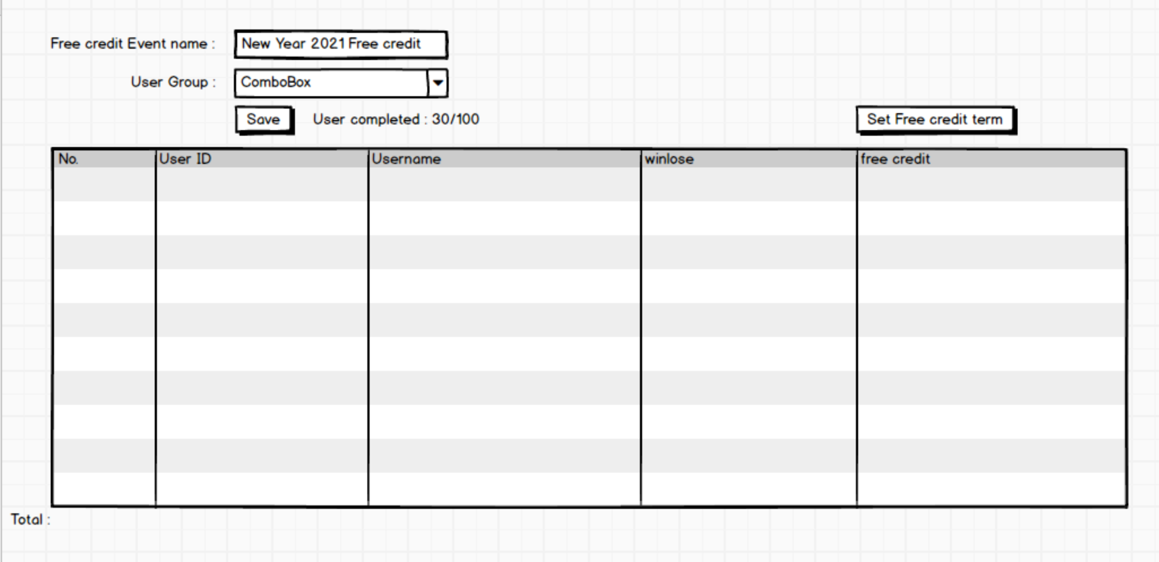

1. admin click add new free credit, admin have to select which user group and data grid will show all user group’s user in the grid.
2. When admin click save, will save into new DB table, and the status columns is false, and when the user main wallet added free credit, the status will become true.
3. If free credit event total user are having 100 users, but the SP running half, only running 30 users is added free credit into user main wallet, remaining 70 users, maybe server is down or disconnected cause this issue happening, admin will go to this page and click the save button again, the SP will running remaining 70 users which status is false.
4. Example this user group is 100 users, while this free credit event is completed 100%, all user is added free credit, but admin is missing one user, admin go to user group page and add the user ID in to the user, then come to this page, select the user group combo box again, the user will become 101 users in the grid. And admin press save, this free credit event will become 101 users.

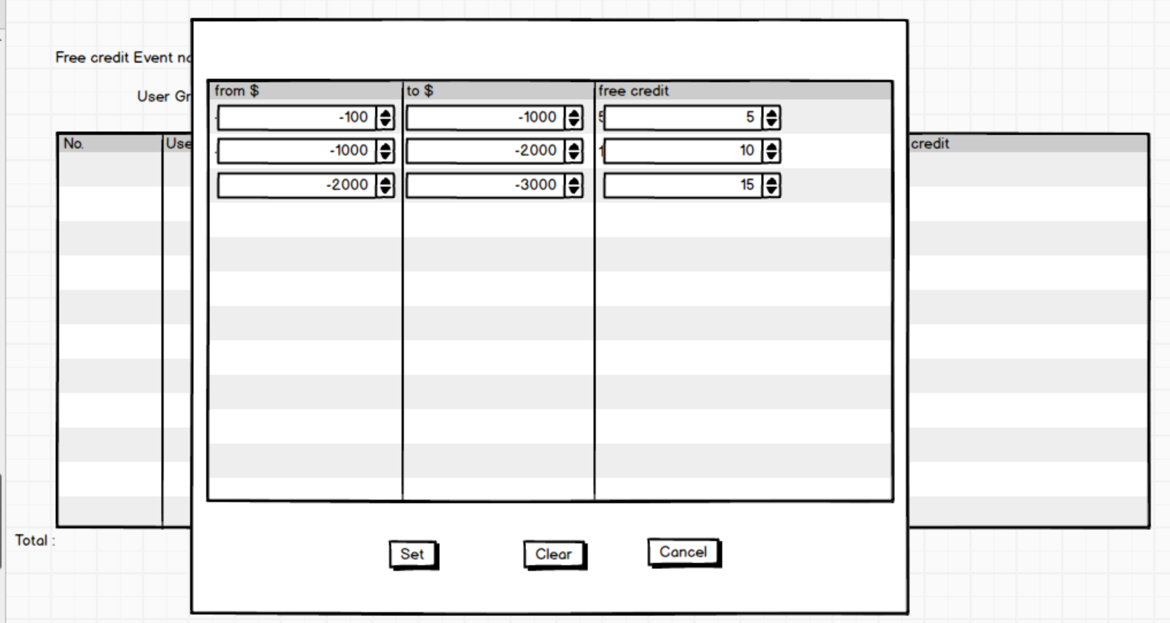

1. admin press set free credit term will pop up this window, example screenshot is losing money from > -100 to < -1000 will get RM5 credit. This winlose value it is getting from usergroup winlose columns, this winlose column feature I was mention last few task in this document
2. when press set , popup window will closed, and free credit event page’s FREE CREDIT column will update the free credit amount.  
     
     
   **4.0 PROMOTION FIXED BONUS AMOUNT**

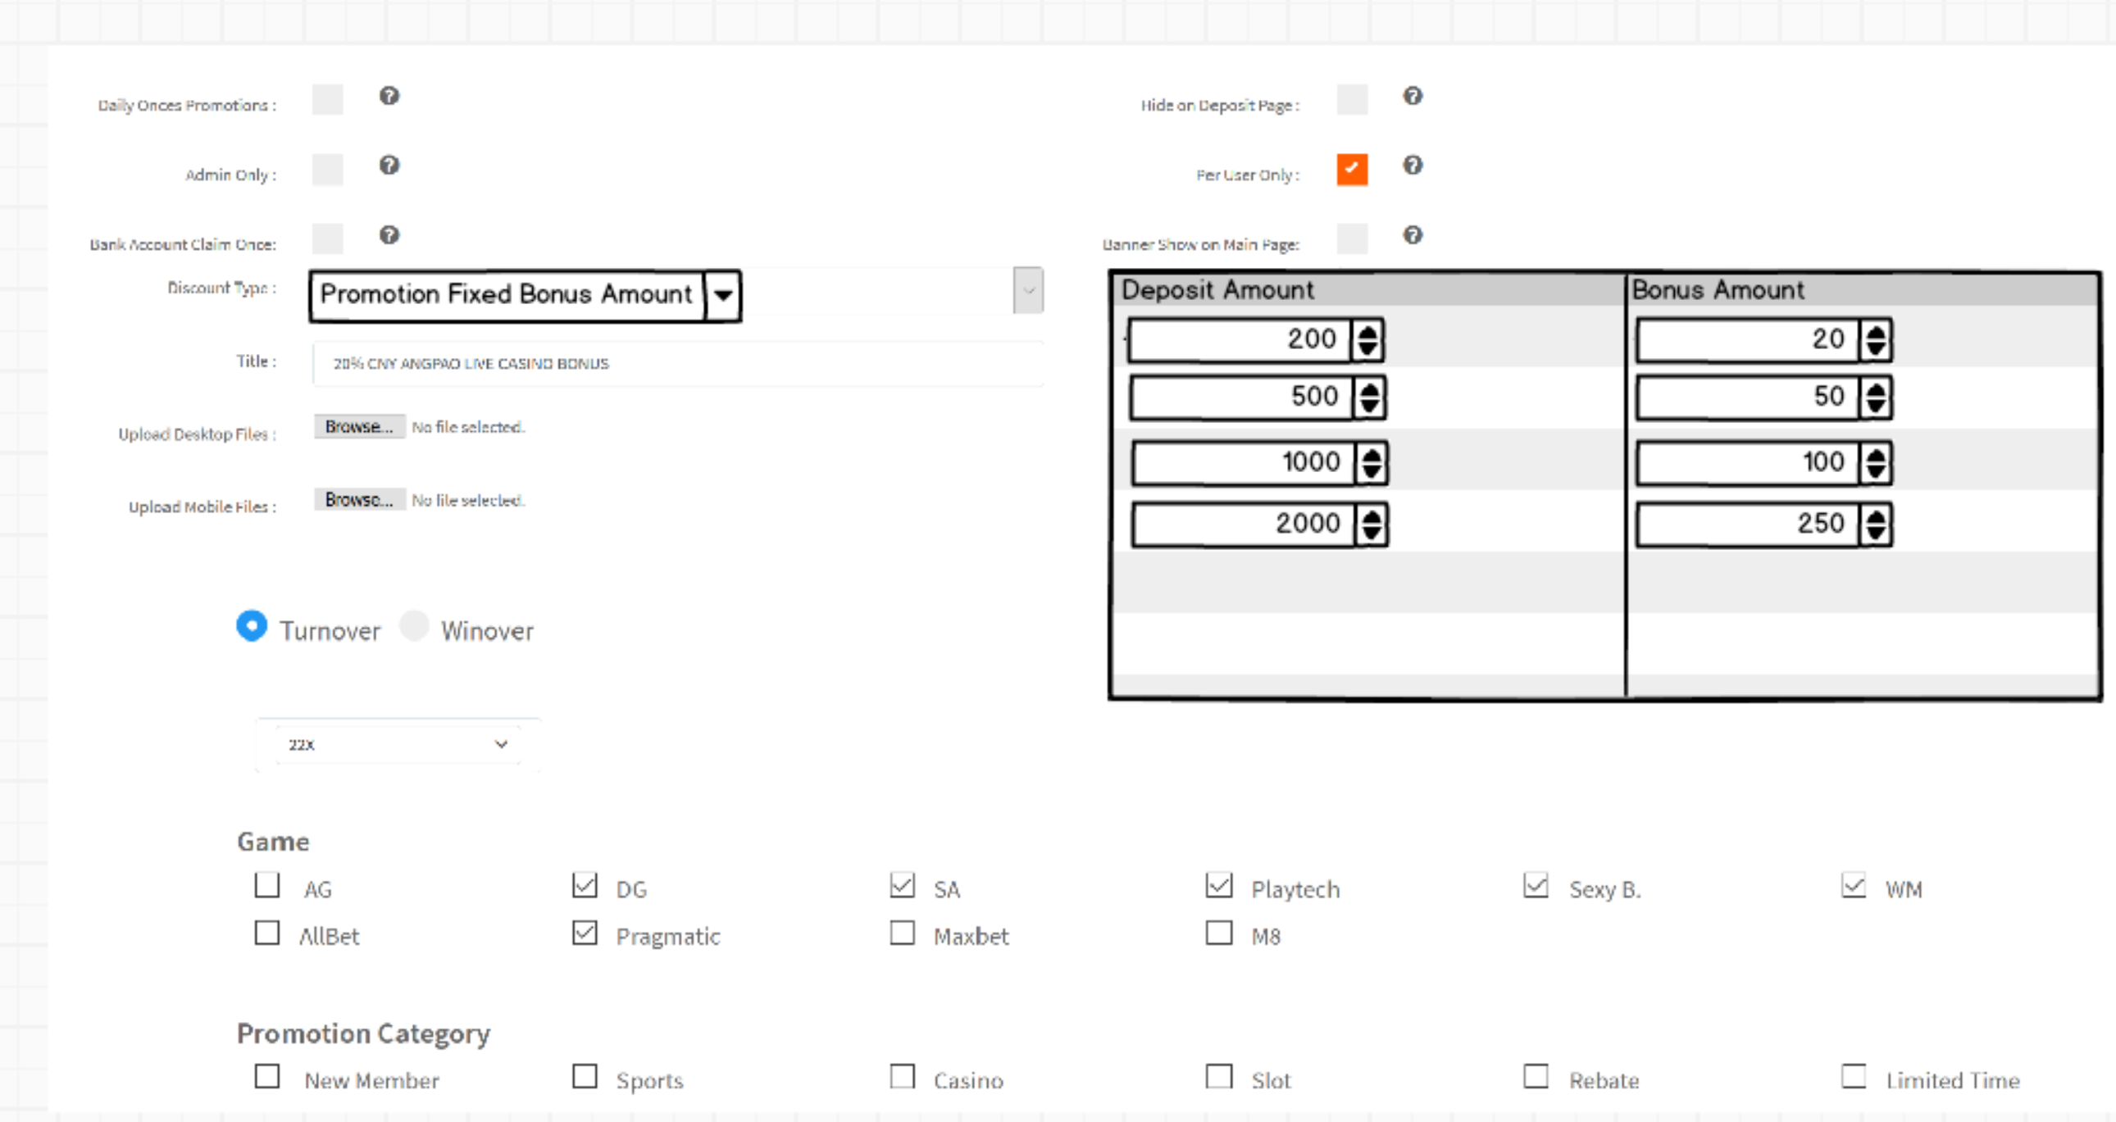

1. add promotion page, discount type will add a new type, it is Promotion Fixed Bonus Amount
2. if the promotion select promotion fixed bonus amount. The others component will hide, and deposit amount grid will show it, setting for how much user deposit and get the bonus amount.
3. If the user deposit 50, and user apply for this promotion, and user press submit button on deposit page, it will prompt error, because deposit amount only allow for 200,500,1000 and 2000 ONLY.
4. Prompt the error show the valid deposit amount example :  
     
   **Your deposit is not correct, only allow below deposit amount :  
   RM200  
   RM500  
   RM1,000  
   RM2,000**
5. This promotion fixed bonus amount normally will use it for promotion code
6. **REMIND :** all promotion must fullfill the turnover target or winover target only withdraw the money

**5.0 PROMOTION CODE REPORT**

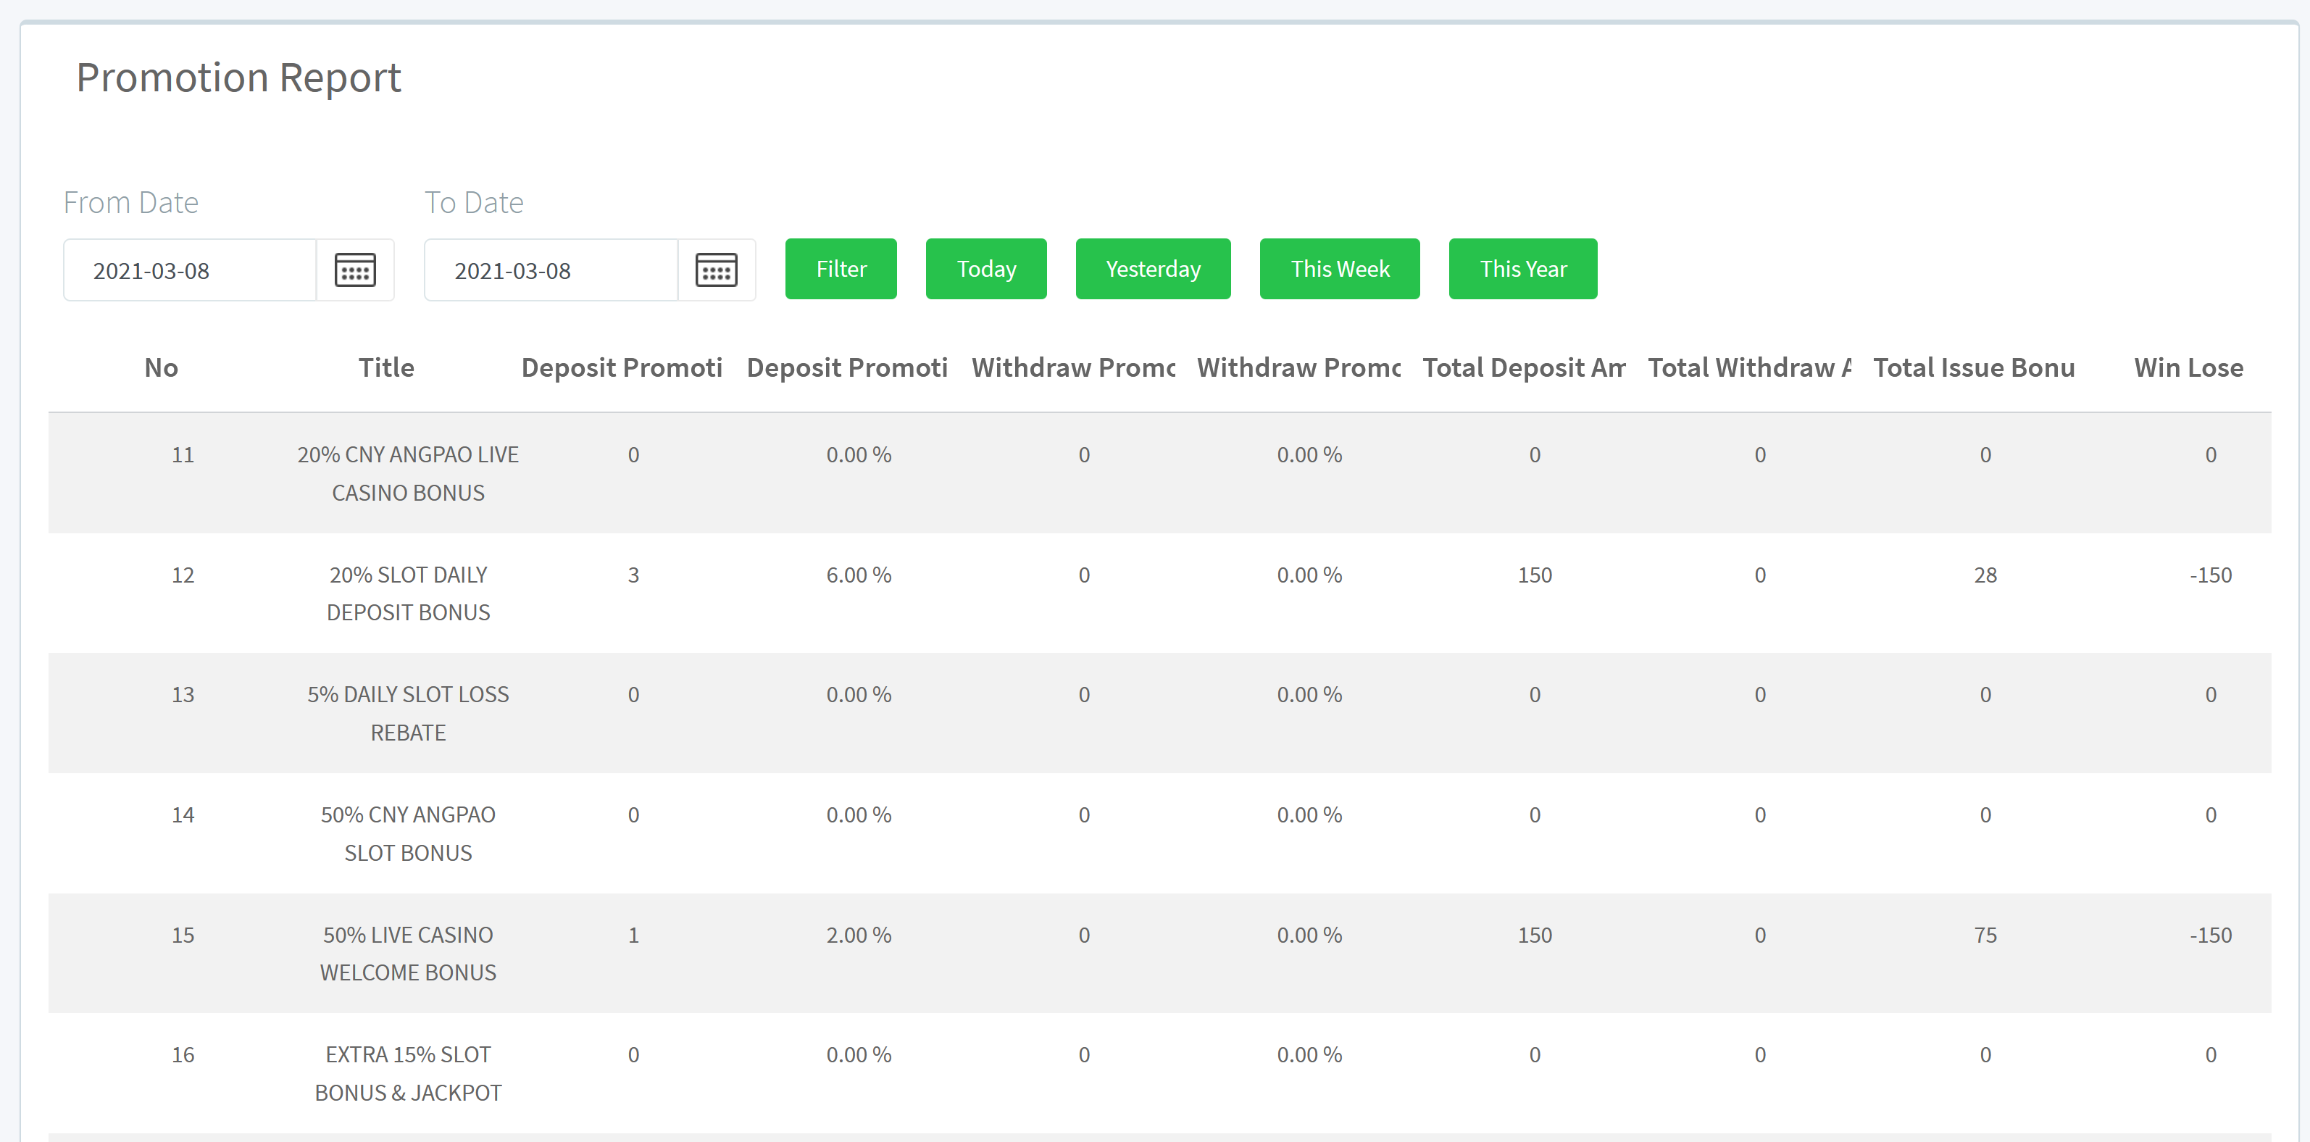

1. create a promotion code report same as promotion report, but the title is promotion code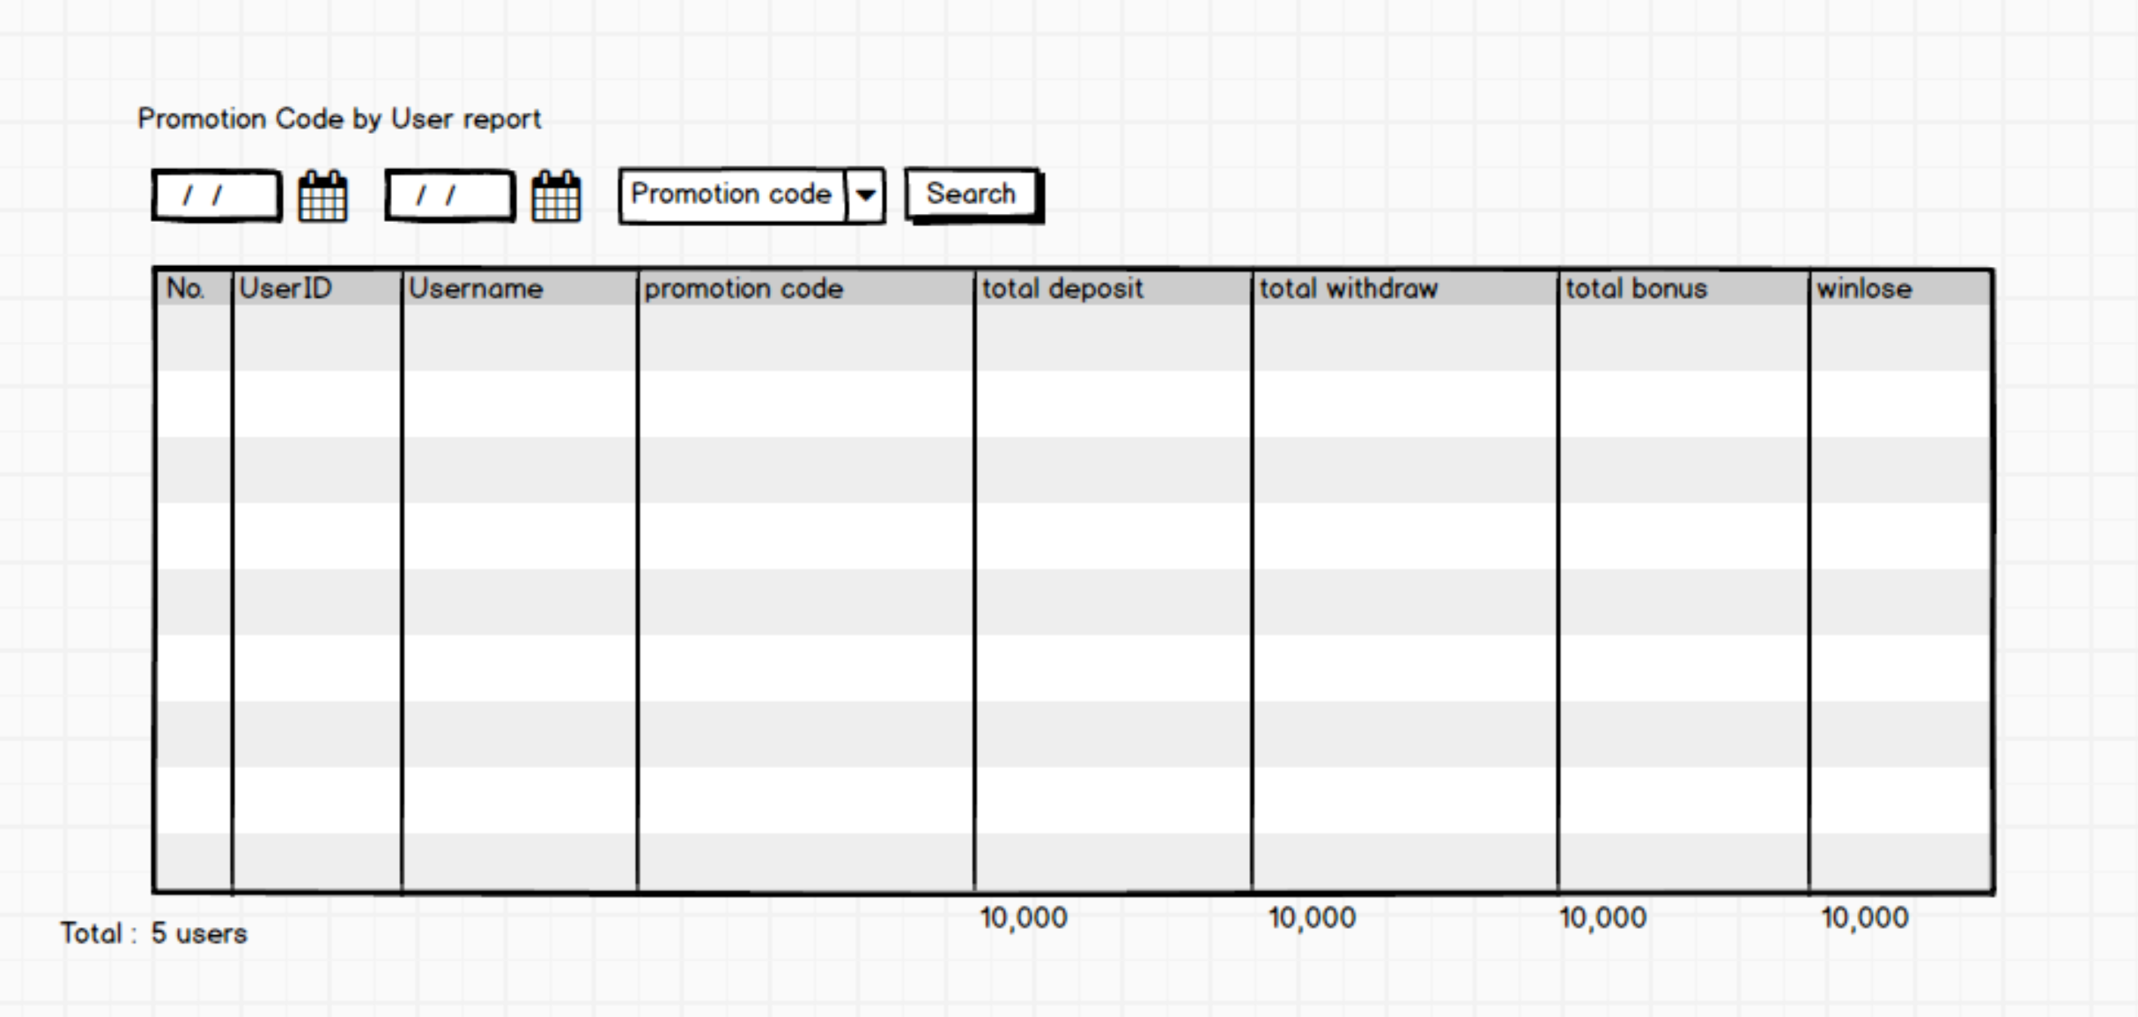
2. promotion code by user report

**Rules of coding**

1. DB relationship must will table primary key ID, like user ID, not using username
2. All DB table remember to add index
3. If u have any better idea of UI design, u can propose